JAGAT J L

Module 3 - PL/SQL Programming
Exercise – 01
Control Structures
Scenario 1: Apply 1% Interest Rate Discount
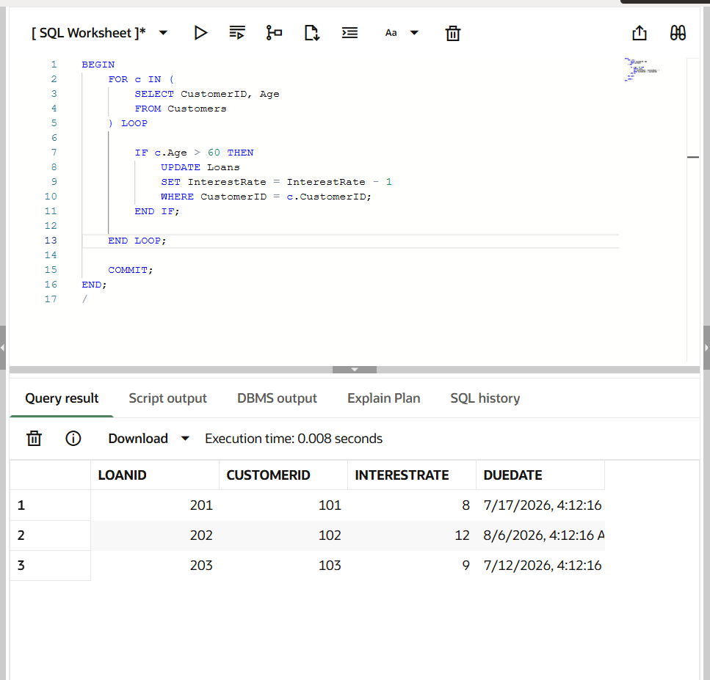

Scenario 2: Promote Customers to VIP
